Data mining Lab 01 – Data preprocessing

Contents

Student information 1

Requirement 1 – Weka installation 2

Requirement 2 – Begin with Weka 3

Requirement 2.1 – Reading data 3

Requirement 2.2 – Exploring weather dataset 7

Requirement 2.3 – Exploring German credit dataset 11

Requirement 3 – Preprocessing implementation 20

# Student information

In this lab, we work in the group of two whose information is shown in the following table:

|  |  |  |
| --- | --- | --- |
| Class | 19KHMT | |
| No | **Student name** | **Student ID** |
| 1 | Do Vuong Phuc | 19127242 |
| 2 | Bui Dang Khoa | 19127645 |

# 

# Requirement 1 – Weka installation

1. **Screenshot of Weka with desktop**

Do Vuong Phuc’s screenshot:

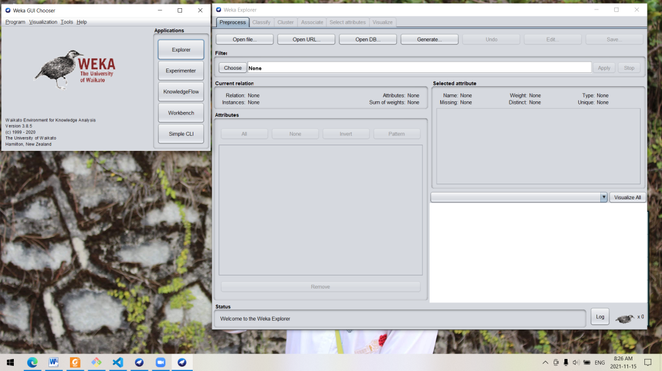

Bui Dang Khoa’s screenshot:

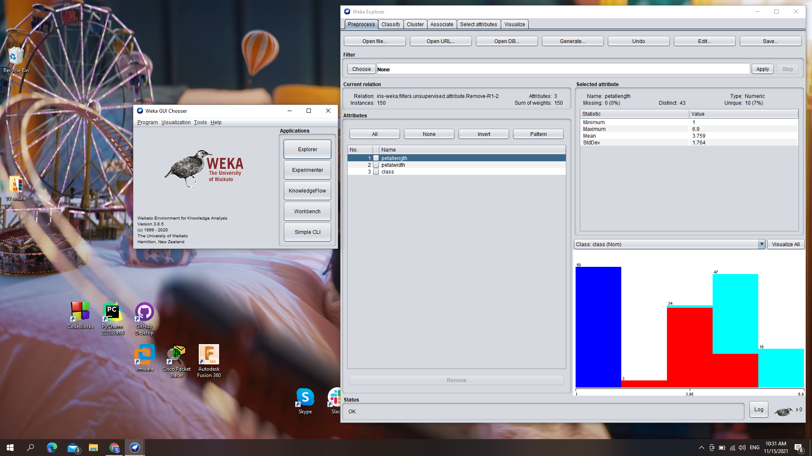

1. **Explanation for groups of preprocess tab:**

* **Filter:** this tab let us filter the data in many way (such as discrete attributes, select the suitable attribute, etc)
* **Current relation:** provides a detailed and intuitive view of the data
  + Relation: show the name of the relationship
  + Instance: number of record in the data (row)
  + Attributes: number of attribute in the data (column)
* **Attributes:** provides the attributes of the relation (has 3 columns)
  + Column 1 (No.): show the numbering of attributes
  + Column 2 (Selected cell): allow user decide which attribute to interact with (such as remove).
  + Name: display name of attribute
  + Instead of selecting one by one attribute, we can use All/None/Invert/Pattern to select attribute
  + We can use “Remove” button to remove the attribute out of the relation
* **Selected attribute:** display the feature and information of each selected attribute
  + Name: display name of selected attribute
  + Type: the type of attribute (Nominal or Numeric)
  + Missing: number and rateof missing value of selected attribute.
  + Distinct: number of distinct value of selected attribute.
  + Unique: number and rate of unique value of selected attribute.
  + Underneath these information, we can see the properties of each value for the selected attribute (including: numbering, label (value), counting sample and its total weight)
  + Moreover, at the bottom, you can see the visualize of the **class** values. If you click, visualize all, it gives you the visualization by each attribute
* **Status:**
  + Log: show history of work

1. **Explanation tabs:**

* Preprocess: manipulate the data before processing data.
* Classify: train and valid the classification model or regression model
* Cluster: clustering the data or divide data into clusters
* Associate: generate association rules from data
* Select attributes: choose the most suitable attribute base on the metric
* Visualize: graphical representation of information and data

# Requirement 2 – Begin with Weka

## Requirement 2.1 – Reading data

1. **How many instance are there?**

Number of instance: 286 instances

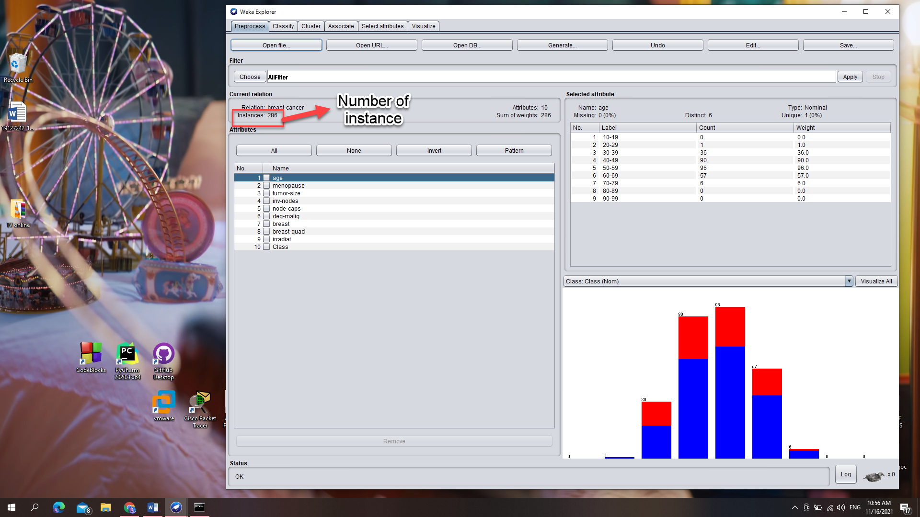

1. **How many attributes does an instance have?**

Number of attributes: 10 attributes

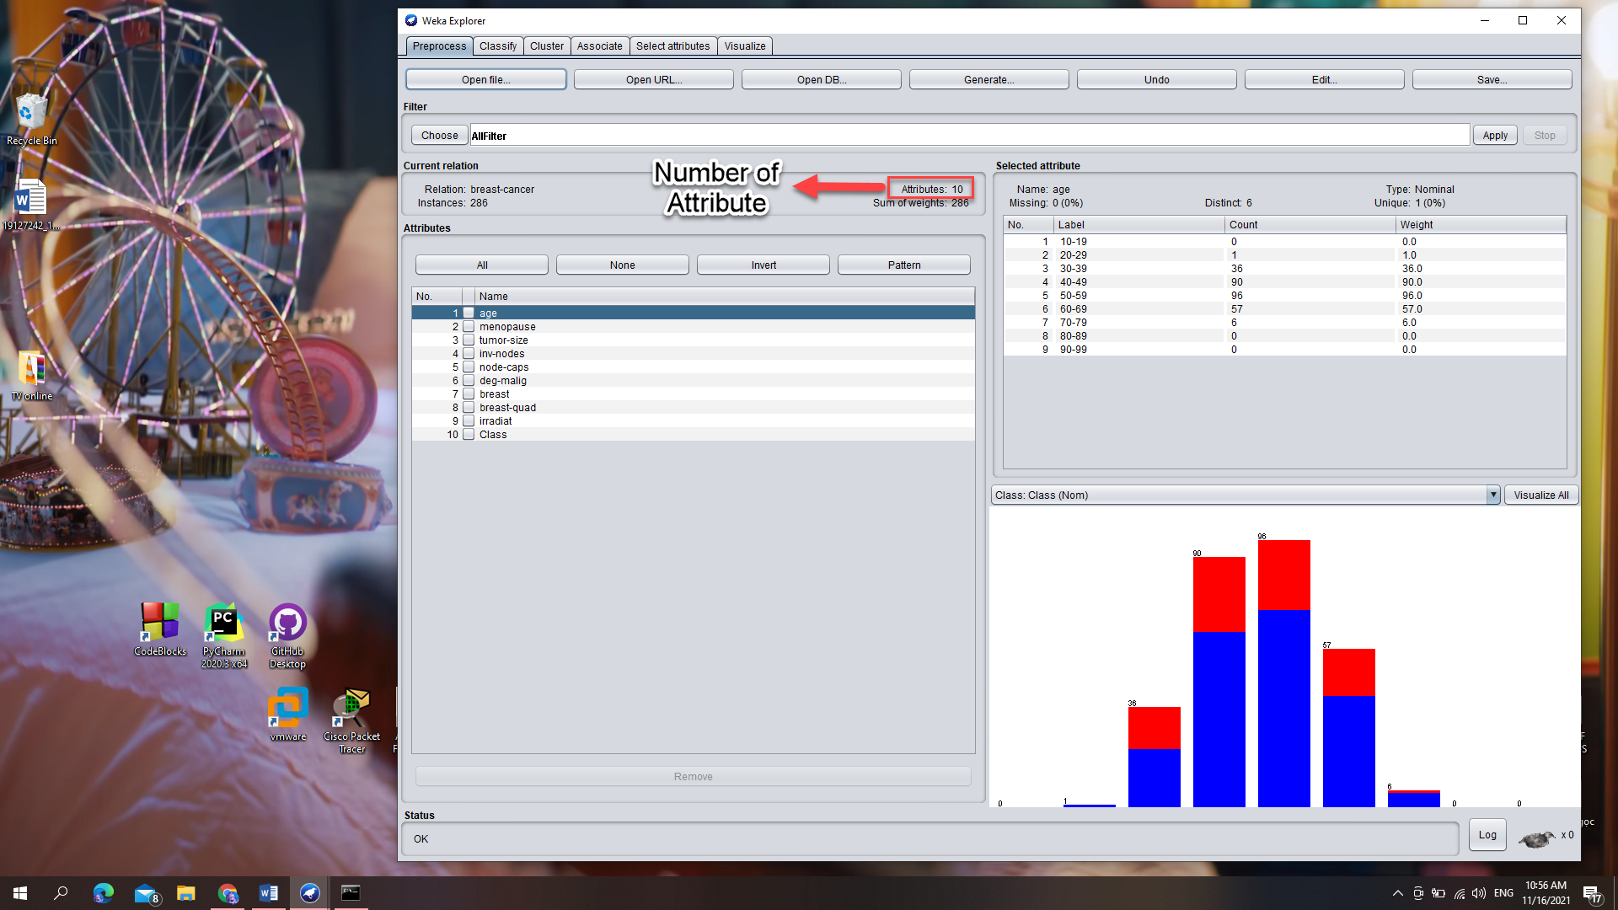

1. **Which attribute represents for the class? Can we change the class attribute and how?**

Attribute **“Class”** is being class. To change the class attribute, we select the drop down list whose label “Class” above the graph, then choose the attribute we want.

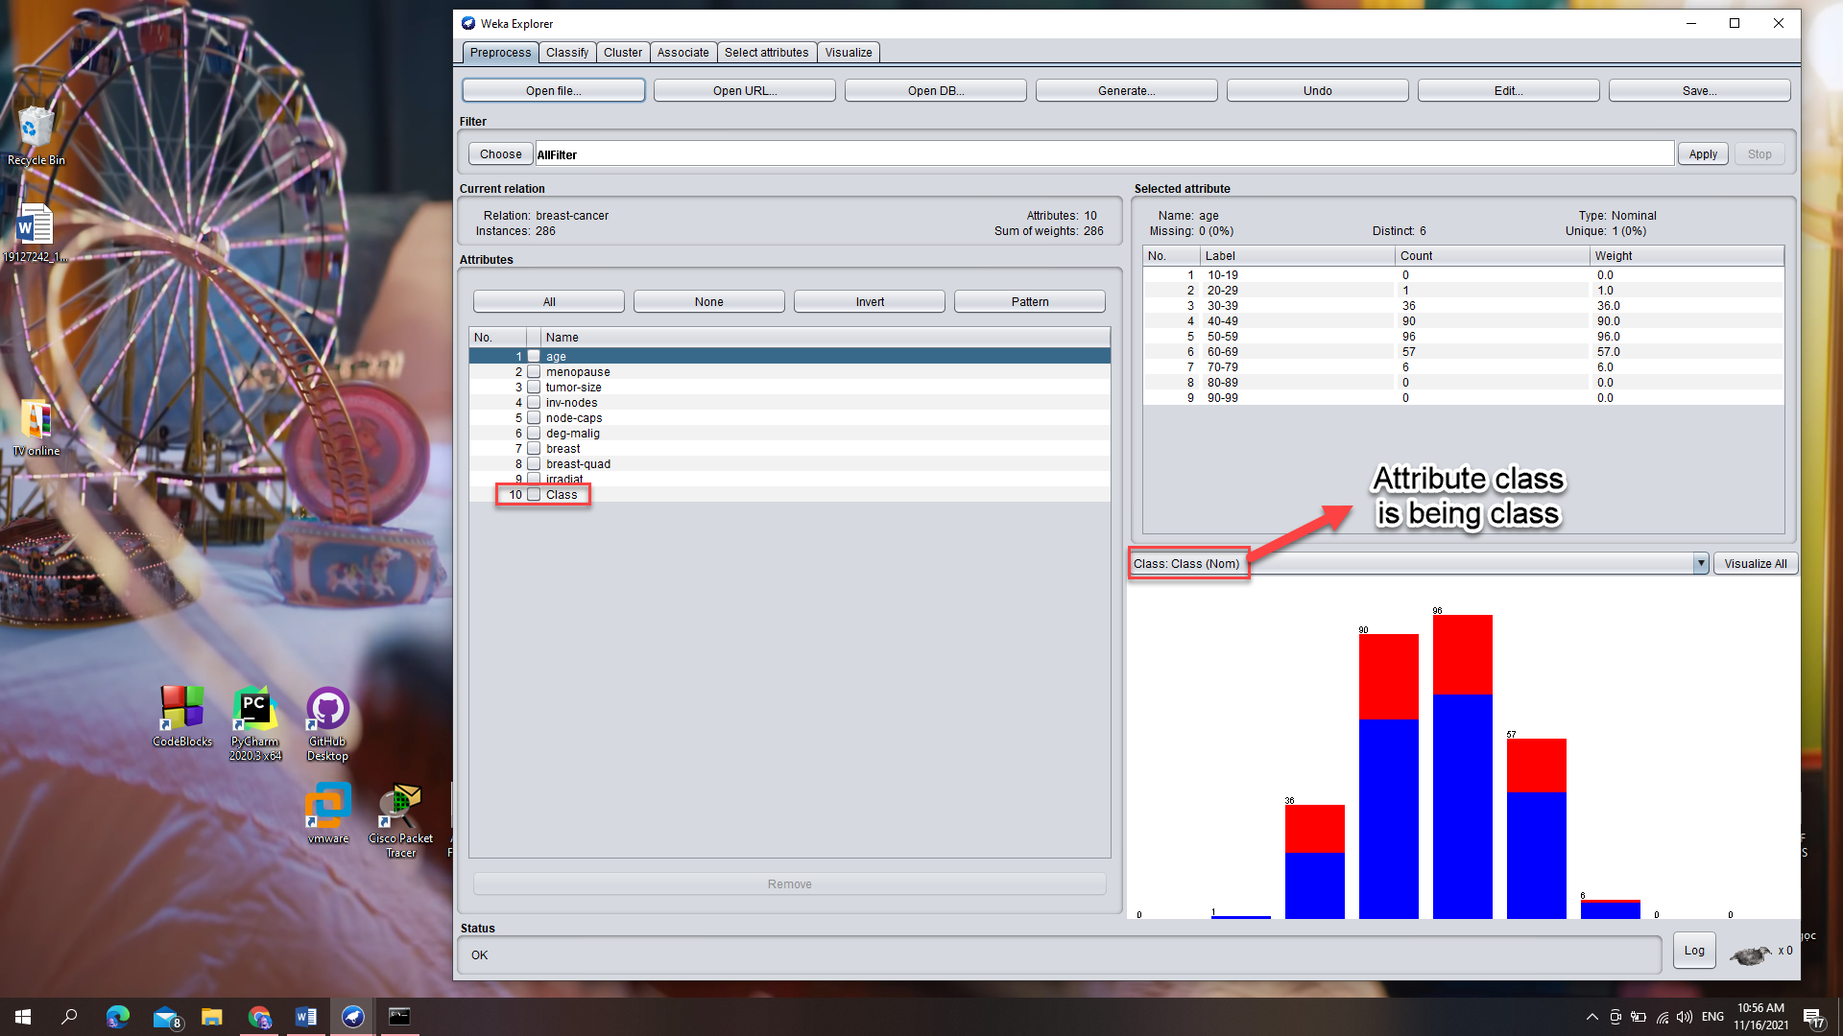

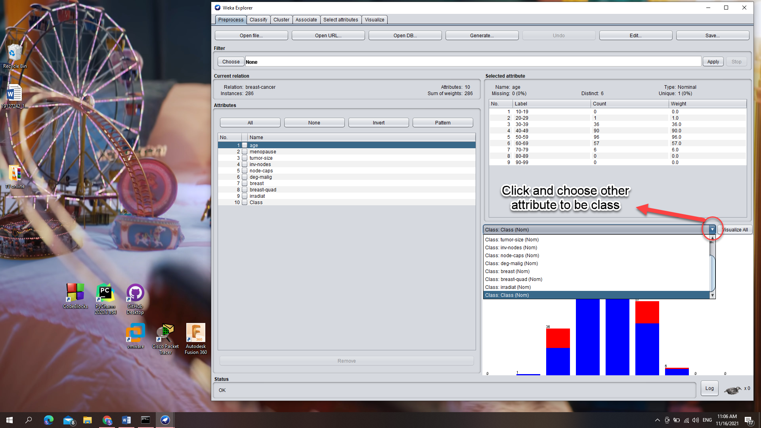

Moreover, we can see and change the attribute class by editing the data:

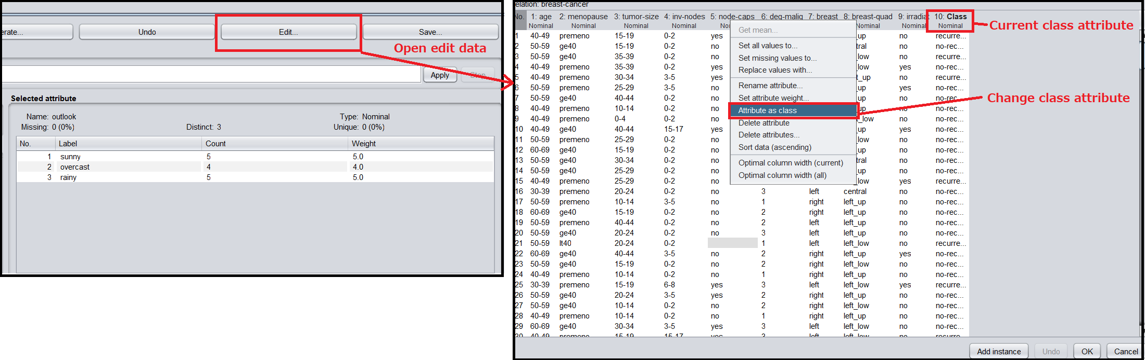

1. **For each attribute, how many missing values are there? Which attribute is the most (and the least) missing? How can we deal with the missing problem?**

* The most missing: “node-caps” attribute (8 samples, 3%)
* The least missing: Age, Menopause, Tumor-size, Inv-nodes, Deg-malig, Breast, Irradiat, Class attributes (0 samples, 0%)
* The following table show the number of missing sample for each attribute:

|  |  |
| --- | --- |
| Attribute | Missing |
| Age | 0 (0%) |
| Menopause | 0 (0%) |
| Tumor-size | 0 (0%) |
| Inv-nodes | 0 (0%) |
| Node-caps | 8 (3%) |
| Deg-malig | 0 (0%) |
| Breast | 0 (0%) |
| Breast-quad | 1 (0%) |
| Irradiat | 0 (0%) |
| Class | 0 (0%) |

* To deal with the missing problem, we can:
  + Delete the attribute whose sample is missing
  + Delete the samples whose attribute is missing
  + Data imputation: Fill the missing with mean, median, mode; or using K-NN, Linear regression; or fill with -1, -99, -999

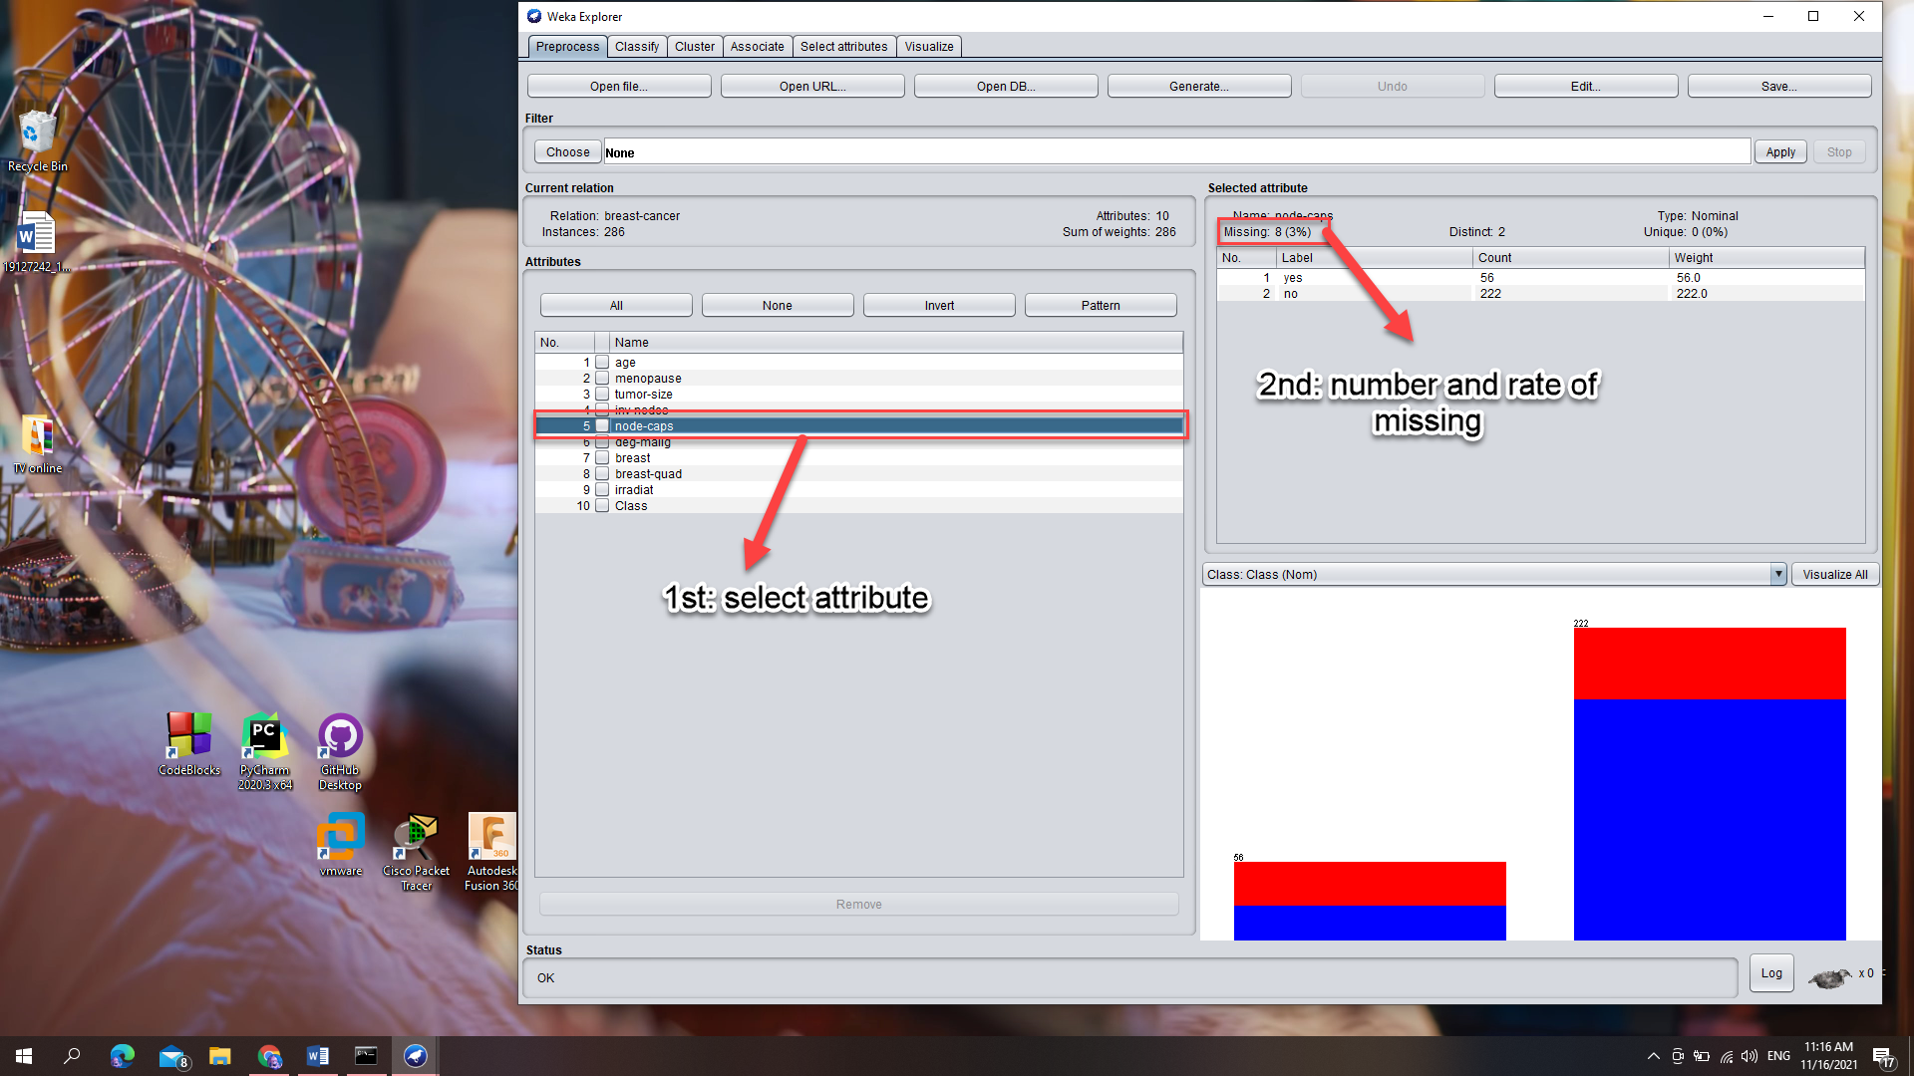

1. **Explain the meaning of graphs of Explorer window. What name is the most suitable for the graph if you have to assign to it? What is represented for the red and blue color? What does the graph represent for?**

The graph shows the distribution of the selected attribute. Each column is represented for a value of the attribute and the colors stand for the class attribute. For instance, the picture below shows that there are 152 value of left and 134 value of right one.

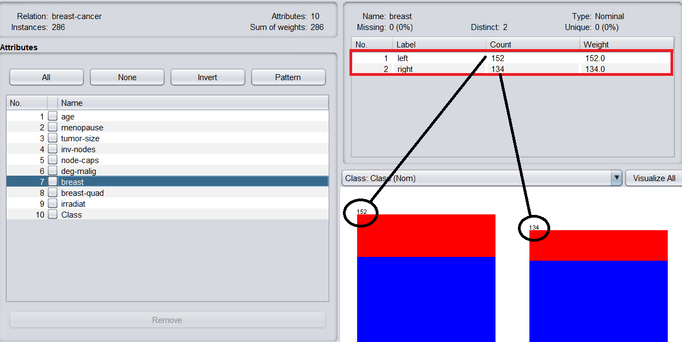

Each color represents for a value of class attribute, in this case:

* Red: recurrence-events
* Blue: no-Recurrence-events

We will know this by clicking on the class attribute and observe its color.

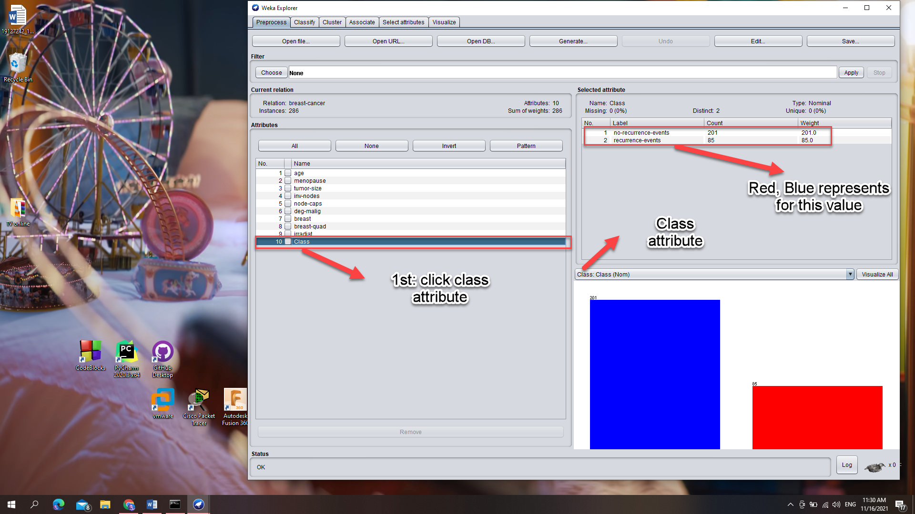

So, we can name the graph as “

## Requirement 2.2 – Exploring weather dataset

1. **How many attributes are there? How many samples? What kind of datatype for each attribute? Which attribute is class attribute?**

Number of sample: 14 samples

Number of attribute: 5 attributes

In “selected attribute” tab, we can see the “Type” of each attribute. The datatypes of each attribute are:

* Nominal: outlook, windy, play
* Numeric: temperature, humidity

Class attribute:play

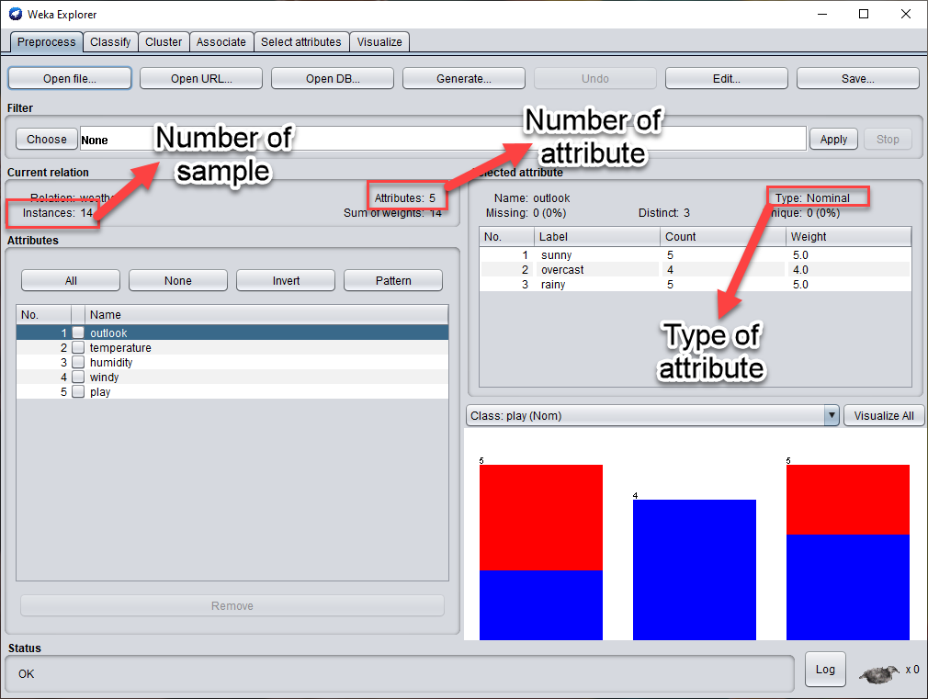

1. **List down five-number summary of tempurature and humidity. Does Weka provides any feature to calculate this?**

Weka does not provide any feature that have us the calculate the five-number summary of the attribute. To find these summary, we sort the data ascendingly using the “edit” feature:

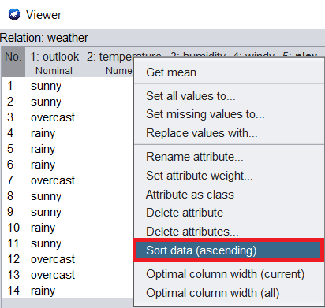

For the tempurature:

* Min (0%): 64
* Q1 (25%): 69
* Median (50%): 72
* Q3 (75%): 80
* Max (100%): 85

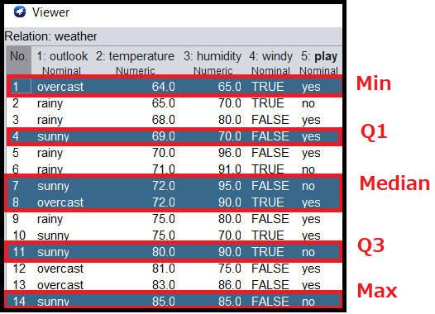

For the humidity:

* Min (0%): 65
* Q1 (25%): 70
* Median (50%): 82.5
* Q3 (75%): 90
* Max (100%): 96

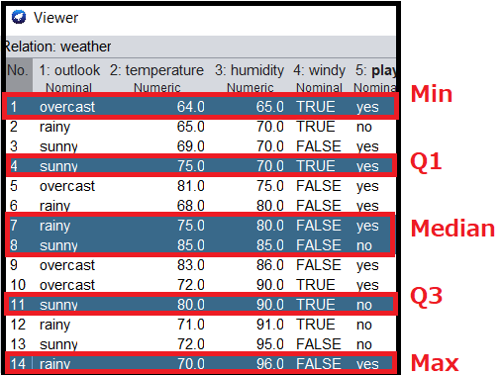

1. **Alternatively look at the graph of each attribute and take screenshot?**

Click “Visualize All” to look at the graph of each attribute.

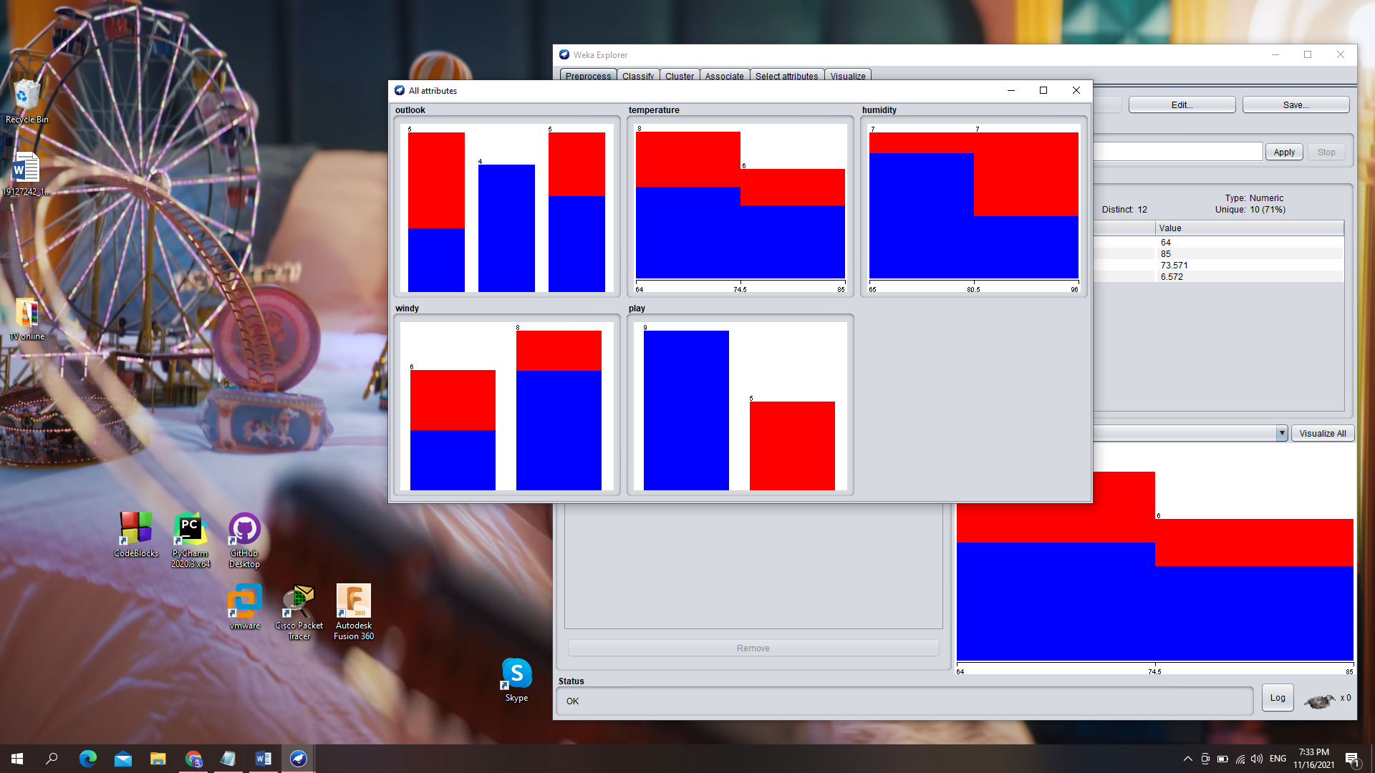

1. **What is the terminology we call the graph in “Visualize” tab? Choose the appropriate jitter to see the distribution better? In your opinion, which is the pair of different attributes that one attribute correlate with the other one?**

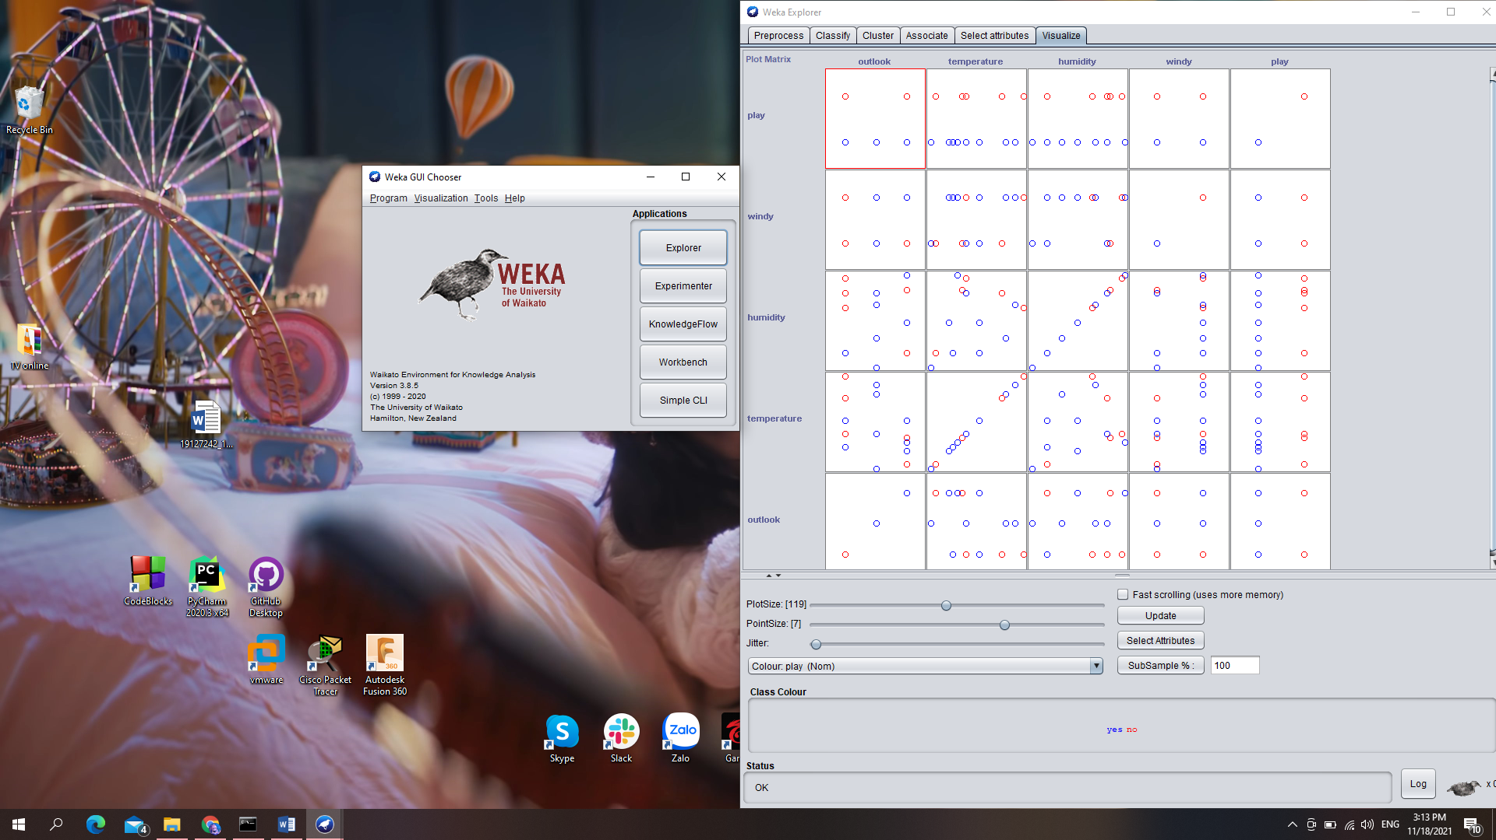

The terminology for this graph is called “pairwise scatterplot matrix”. In our opinion, the pair of attributes which have the most correlative is “Outlook” and “Tempurature” since the tempurature is low whenever it rains; and high as sunny.

## Requirement 2.3 – Exploring German credit dataset

1. **What did the comment of the dataset say? How many instances and attributes are there? Describe 5 attribute arbitrarily (must have both discrete and continuous)**

Comment of the dataset said:

* Section 1: title of data (German credit data)
* Section 2: source information (Dr. Hans Hofmann, etc)
* Section 3: number of instance which is 1000 instances
* There are 2 dataset (categorical and numerical)
* Section 6: the number of attribute. We use data “credit-g.arff”, don’t use “credit-g.numer.arff”
  + File “german”: 20 attributes (7 numerical, 13 categorical) without class attribute
  + File “german.numer”: 24 attributes (24 numerical) without class attribute
* Section 7: describes the meaning of attributes for “german” (credit-g.arff) file
* Section 8: provide the cost matrix for class attribute; and value for attributes
* Notice that the section 7 only provides the meaning of attribute, not their values. Their values is relabeled in section 8.

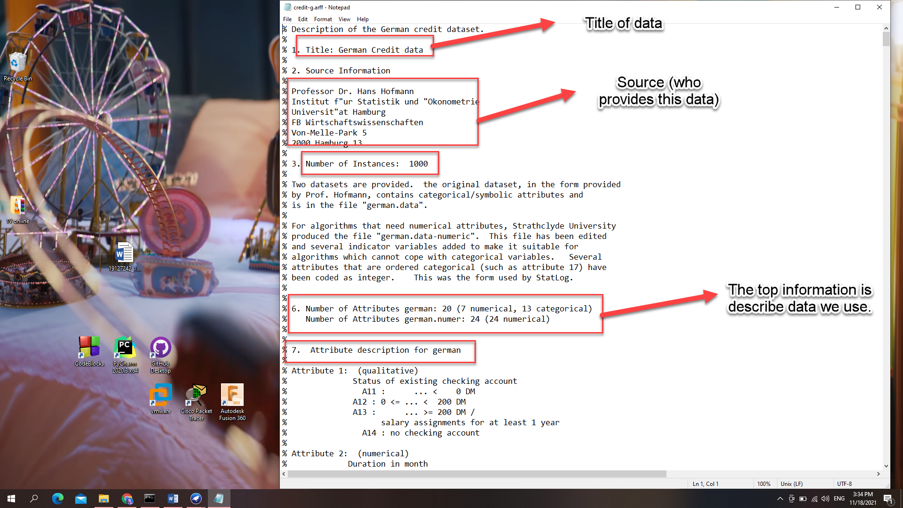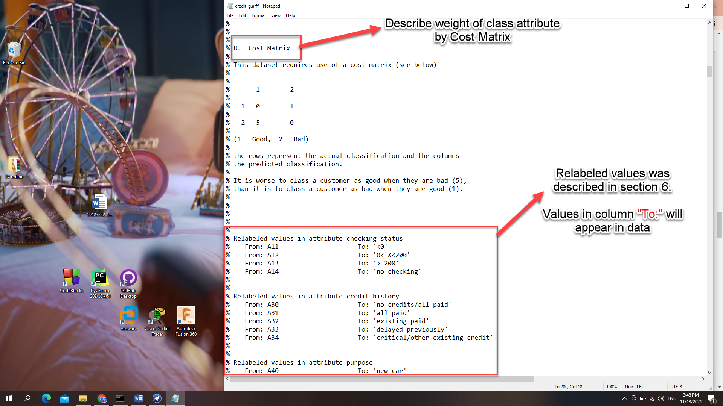

**Describe 5 attributes:**

* Attribute 5 (numerical):
  + Credit Amount
* Attribute 6 (qualitative):
  + Saving account/bonds
  + Have 5 values:
    - Value 1 (A61): less than 100 DM
    - Value 2 (A62): from 100 DM to 500 DM
    - Value 3 (A63): from 500 DM to 1000 DM
    - Value 4 (A64): More than 1000 DM
    - Value 5 (A65): unknown/no savings account
* Attribute 7: (Qualitative)
  + Present employment since a period of time
  + Have 5 values:
    - Value 1 (A71): unemployed
    - Value 2 (A72): less than 1 year
    - Value 3 (A73): from 1 year to 4 years
    - Value 4 (A74): from 4 years to 7 years
    - Value 5 (A75): more than 7 years
* Attribute 8: (numerical)
  + Installment rate in percentage of disposable income
* Attribute 9: (qualitative)
  + Personal status and sex of the sample
  + Have 5 values:
    - Value 1 (A91): male and divorced/separated
    - Value 2 (A92): female and divorced/separated/married
    - Value 3 (A93): male and single
    - Value 4 (A94): male and married/widowed
    - Value 5 (A95): female and single

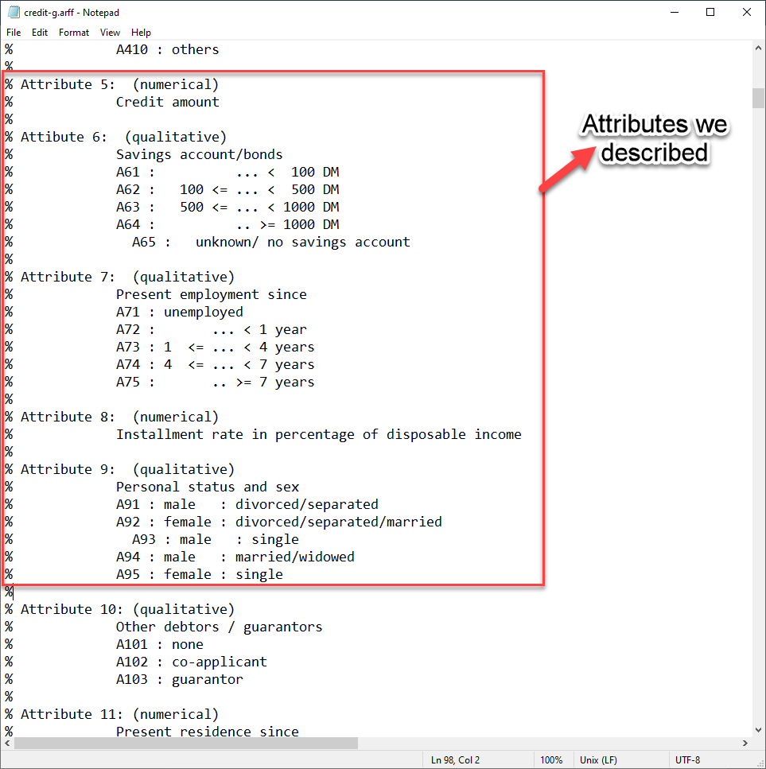

1. **Which attribute is the class attribute? Evaluate the distribution of classes, means that is it balance or being skew?**

**“Class”** is name of the class attribute and the distribution of classes is skew to “good” value.

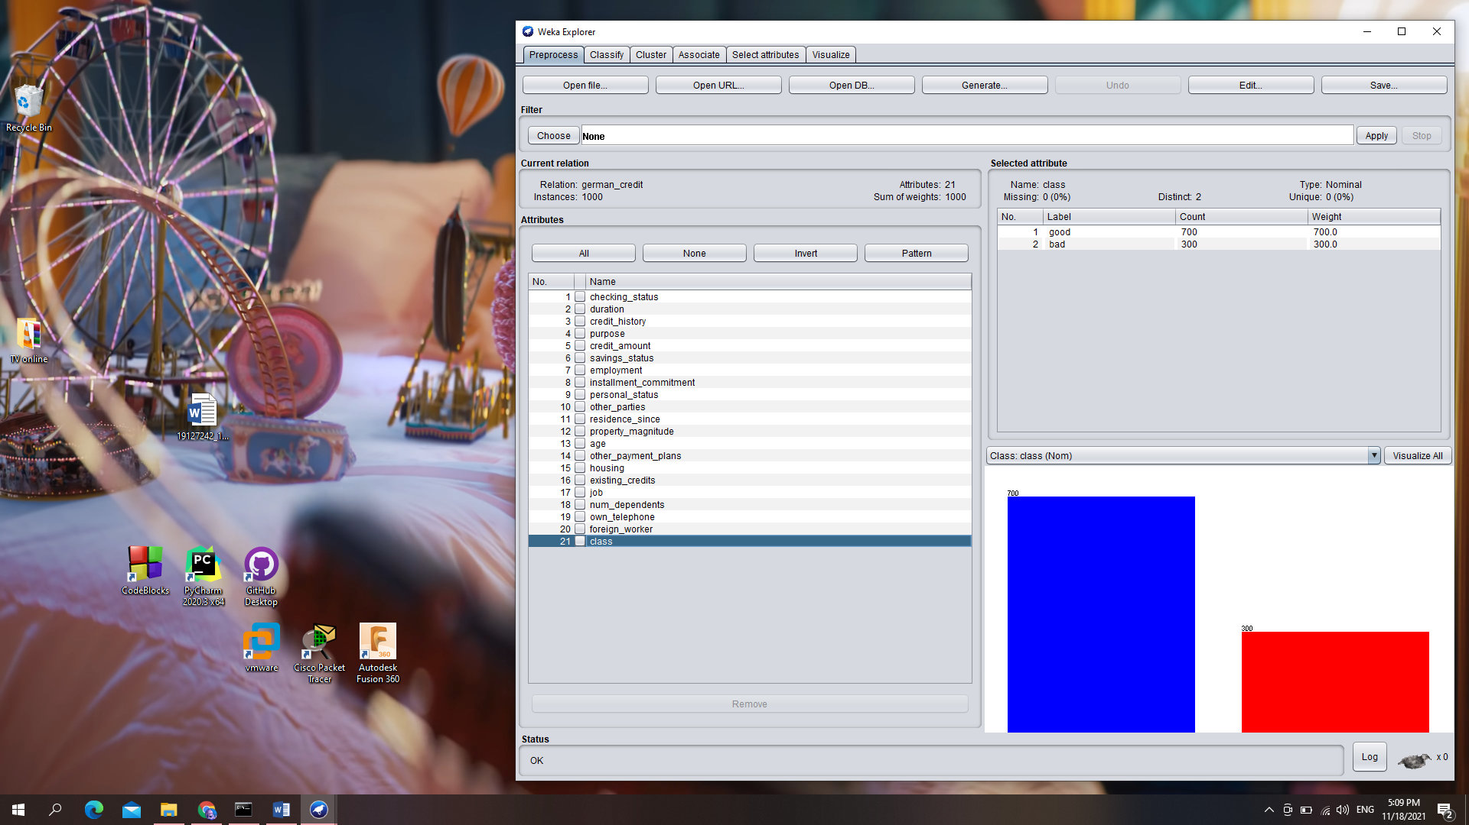

1. **Using the “Select attribute” tab, list down and describe briefly for each method**
2. Correlation Based Feature Selection (CorrelationAttributeEval):

Calculate the correlation (Pearson’s) between each attribute and the class attribute. There are three kinds of Pearson’s correlation: Positive, Neural and Negative.

After using this technique, we can choose the moderate to high positive or negative correlation and drop the neural (low correlation) one.

For instance, we tested this feature on the weather dataset for the “outlook” class and achieved that the most correlative attribute is “tempurature”.

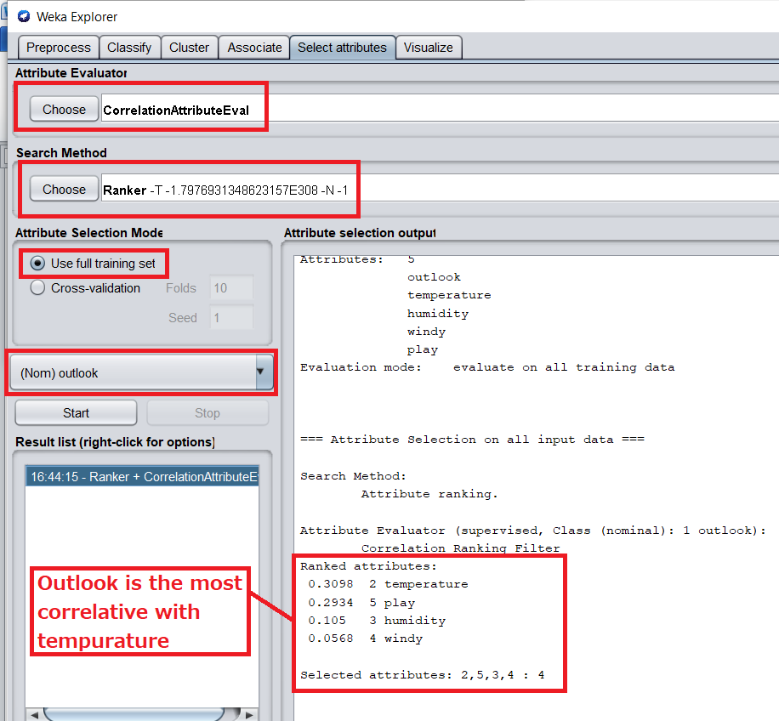

1. Information Gain Based Feature Selection (InfoGainAttributeEval):

Calculate the information gain (also called [entropy](https://en.wikipedia.org/wiki/Entropy_(information_theory))) for each attribute for the output variable. The value is in range from 0 (no information) to 1 (maximum information). Those attributes that contribute more information will have a higher information gain value which can be selected. On the other hand, the low information gain attribute can be removed. This also used to execute the ID3 algorithm (Decision tree).

1. Learner Based Feature Selection (WrapperSubsetEval):

The subset that results in the best performance is taken as the selected subset. The algorithm used to evaluate the subsets does not have to be the algorithm that you intend to use to model your problem, but it should be generally quick to train and powerful, like a decision tree method.

1. Correlation Based Feature Selection Subset (CfsSubsetEval):

This method evalutes how correlative that a subset (of attributes) to the class attribute.

The subsets whose element are less intercorrelative, but the subset highly correlated to the target class are preferred (elements should as independent as possible)

1. Gain Ratio Attribute evaluation (GainRatioAttributeEval):

This method measures the significance of attributes with respect to target class on the basis of gain ratio. It can be calculated by the following formula,



Where H represents for the Entropy function

1. Classifier Attribute Evaluation (ClassifierAttributeEval):

Evaluates the worth of an attribute by using a user-specified classifier.

1. Classifier subset evaluator (Classifiersubseteval):

Evaluates attribute subsets on training data or a separate hold out testing set.

1. One R Attribute Evaluation (OneRAttributeEval) :

Evaluates the worth of an attribute by using the OneR classifier.

1. Principal components:

Performs a principal components analysis and transformation of the data

1. Relief F Attribute Evaluation (ReliefFAttributeEval):

Evaluates the worth of an attribute by repeatedly sampling an instance and considering the value of the given attribute for the nearest instance of the same and different class.

1. Symmetrical Uncert Attribute Evaluation (SymmetricalUncertAttributeEval) :

Evaluates the worth of an attribute by measuring the symmetrical uncertainty with respect to the class.

1. **Which filter should we use to find out 5 most correlative attributes (to the class attribute)? Describe step-by-step and include the screenshot**

To find the most correlative attributes, we do the following step:

* Step 1: Click “Select Attribute” tab
* Step 2: Choose Attribute Evaluator “Correlation Attribute Eval”
* Step 3: Choose class attribute which is “class”
* Step 4: Choose Search Method “Ranker” with number to select is Top-5
* Step 5: Click Start

And the result show top-5 attributes are: checking_status, duration, credit_amount, savings_status and housing

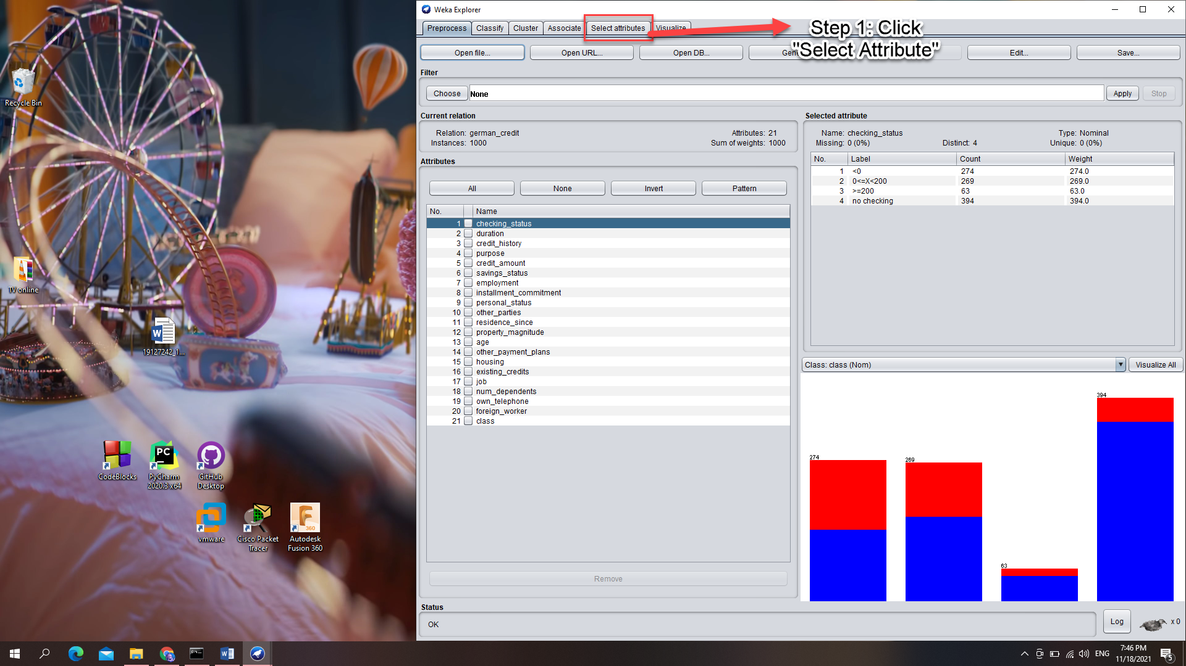

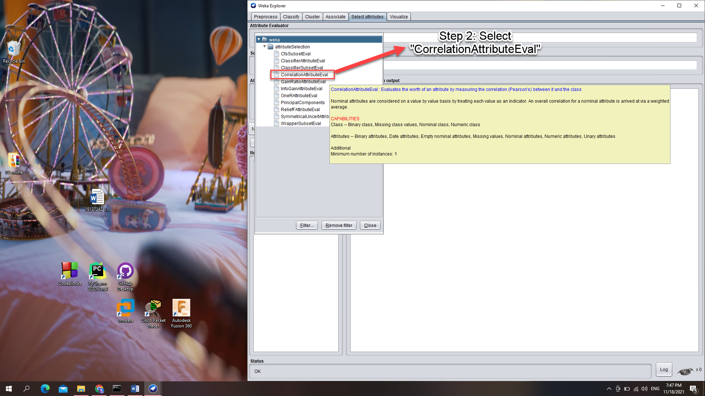

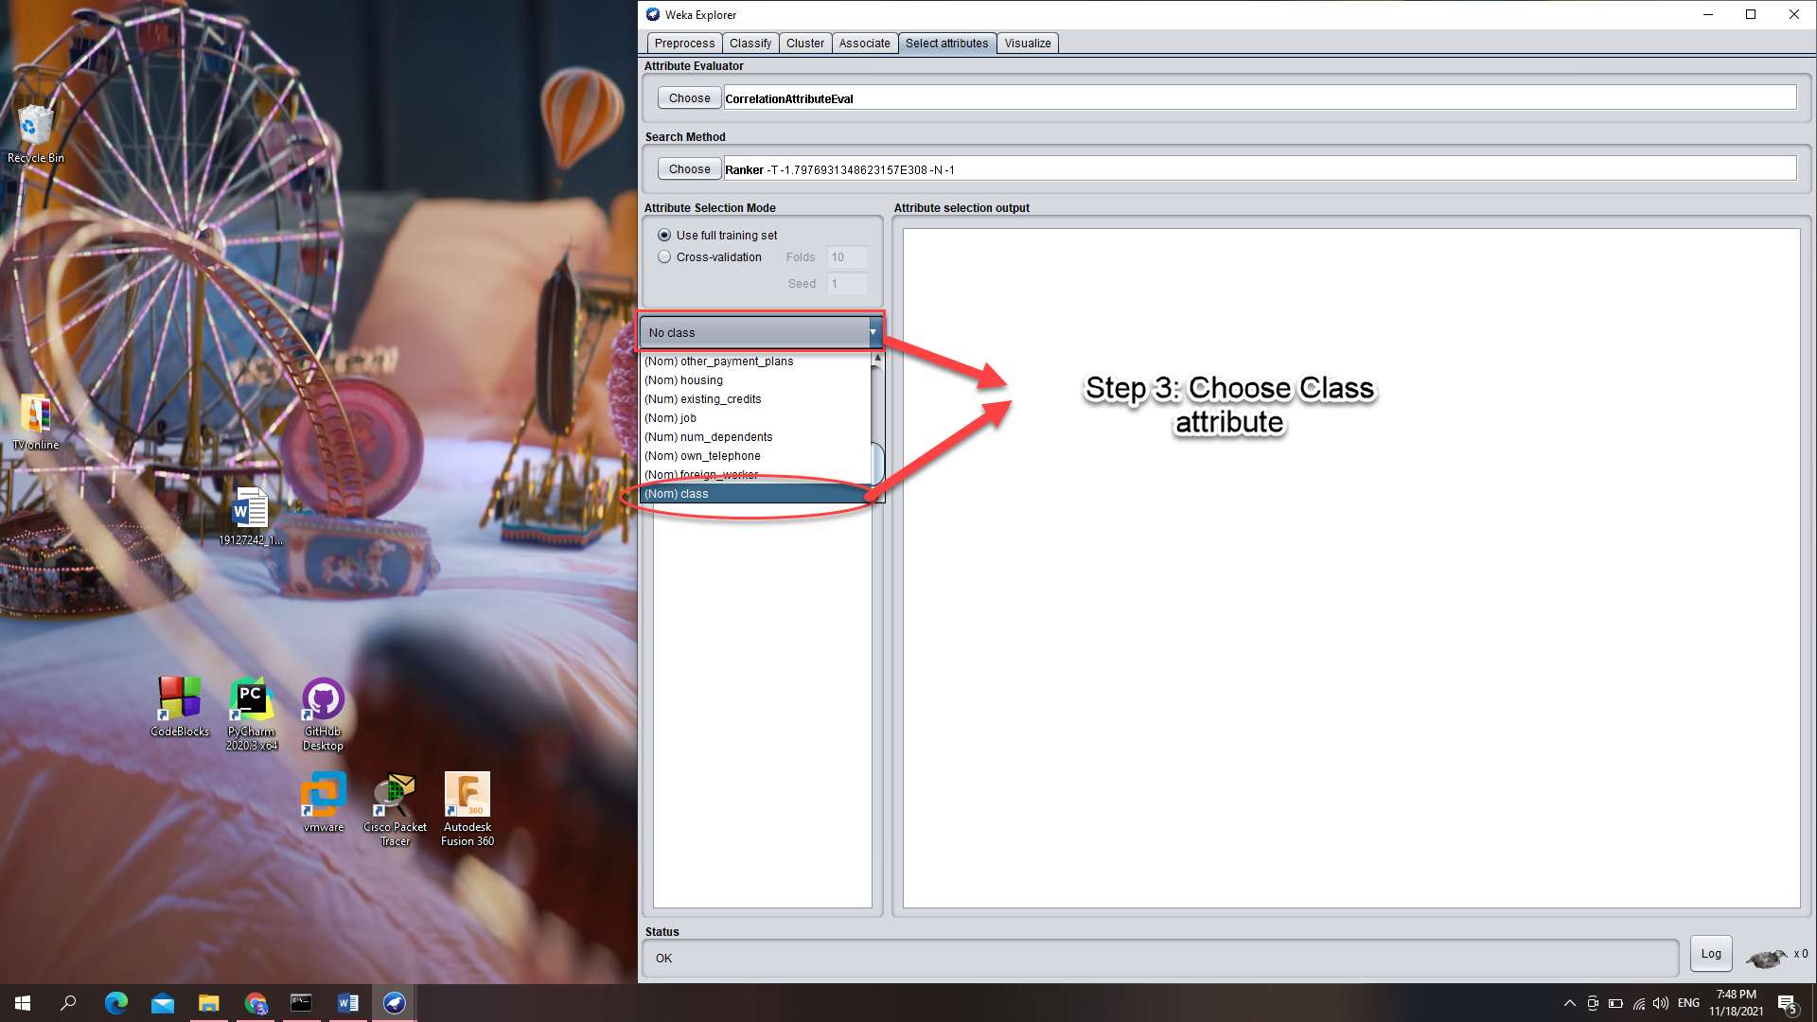

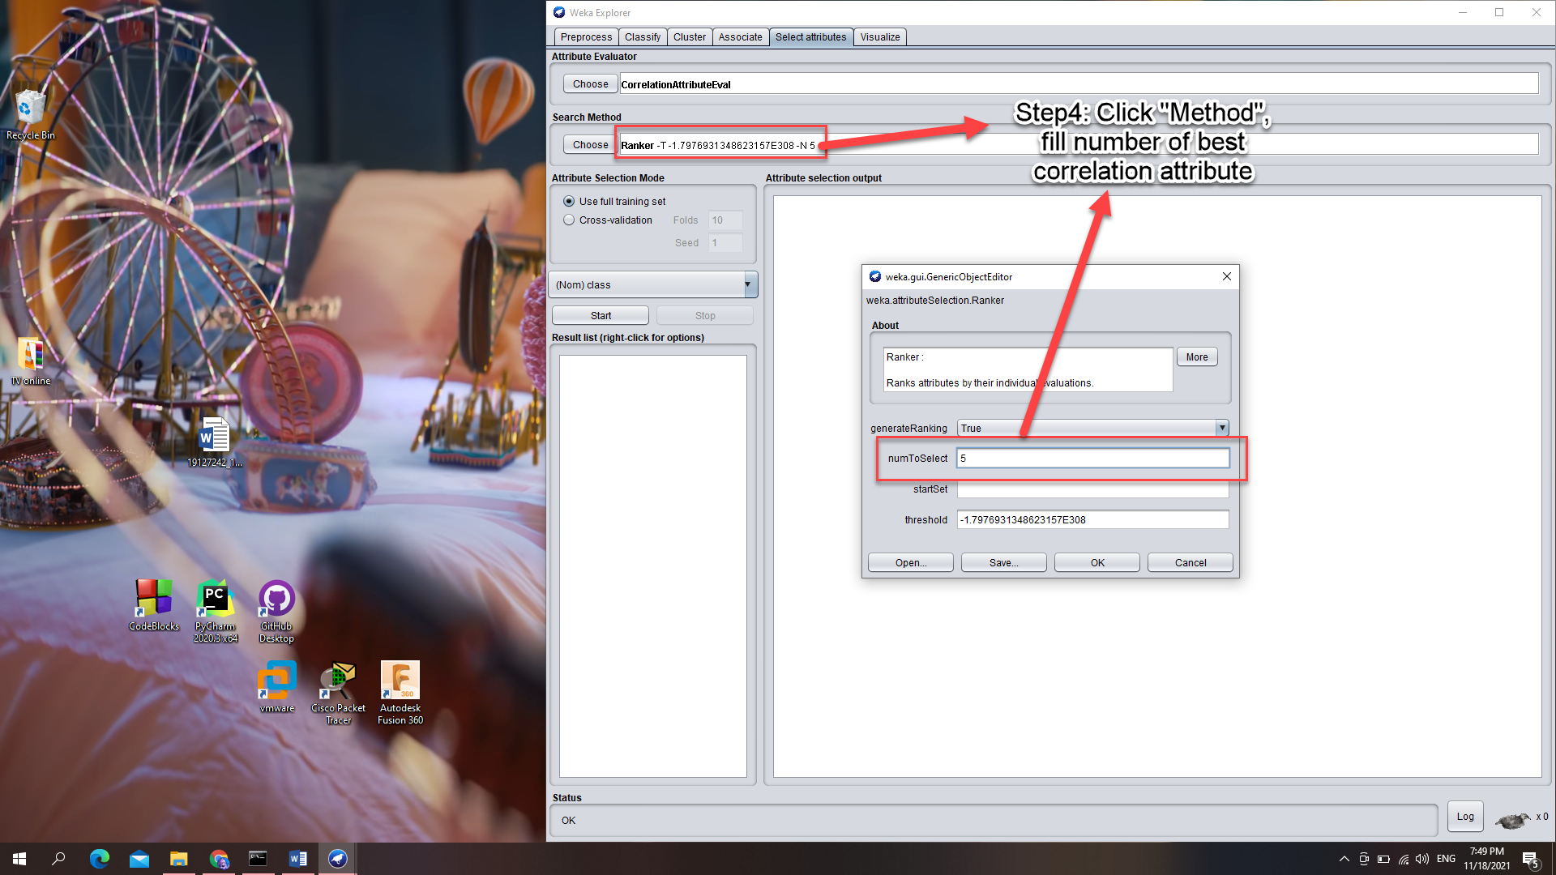

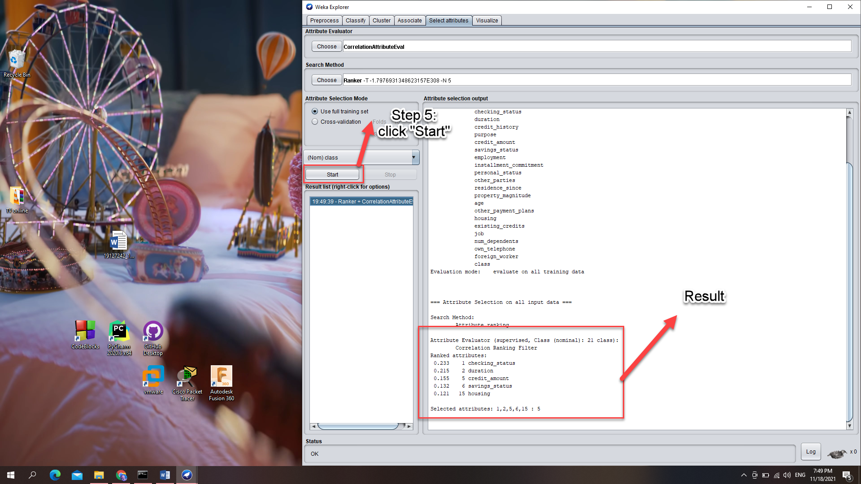

# Requirement 3 – Preprocessing implementation

# References

1. Classification Algorithms with Attribute Selection: an evaluation study using WEKA – Dr. S.Gnamambal et al – 04th Apr, 2018
2. Perform feature selection Machine learning data WEKA – Machine Learning Mastery – Jason Brownlee – 13th July, 2018
3. Machine Learning with WEKA WEKA Explorer Tutorial - S. Aksenova - California State University – 2004
4. Quartiles – Math is fun – 2019
5. A Tour of the Weka Machine Learning Workbench – Jason Brownlee – 21st Jun, 2016
6. Attribute-Relation File Format (ARFF) – University of Waikato – 1st Nov, 2008
7. How to Calculate Correlation Between Variables in Python – Machine Learning Mastery – Jason Brown, 27th Apr, 2018